Chapter 7a: Motors

**(Vector quantities are displayed either in italic Bold or with a vector symbol above the quantity)**

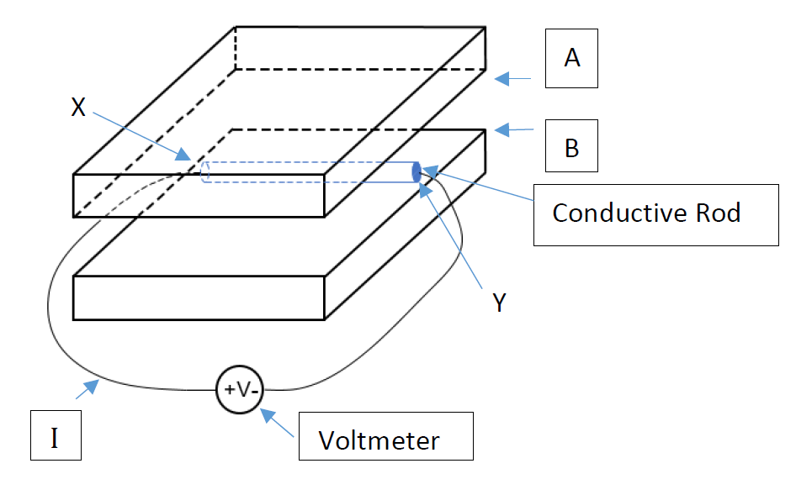

This diagram is for answering Q1 to Q5

1. Given that A is a North pole and B, a South pole, what is the direction of the current, if any, when the rod is moved at a velocity backwards?

The current flows from left to right/ right to left / no current at the point marked by I.

1. Given that A is a North pole and B, a South pole, what is the direction of the voltage when the rod is moved at a velocity backwards?

The end marked X is negative/positive with respect to the end marked Y.

1. Given that A is a South pole and B, a North pole, what is the direction of the voltage when the rod is moved at a velocity backwards?

The end marked X is negative/positive with respect to the end marked Y.

1. Given that A is a North pole and B, a South pole, what is the direction of the Lorentz force generated that acts on the rod, if any, when the rod is moved at a velocity backwards?

The rod experiences a force forward/backward/upward/downward/no force

1. Given that A is a North pole and B, a South pole, and the voltmeter register - 3 V. In which direction is the rod moving?

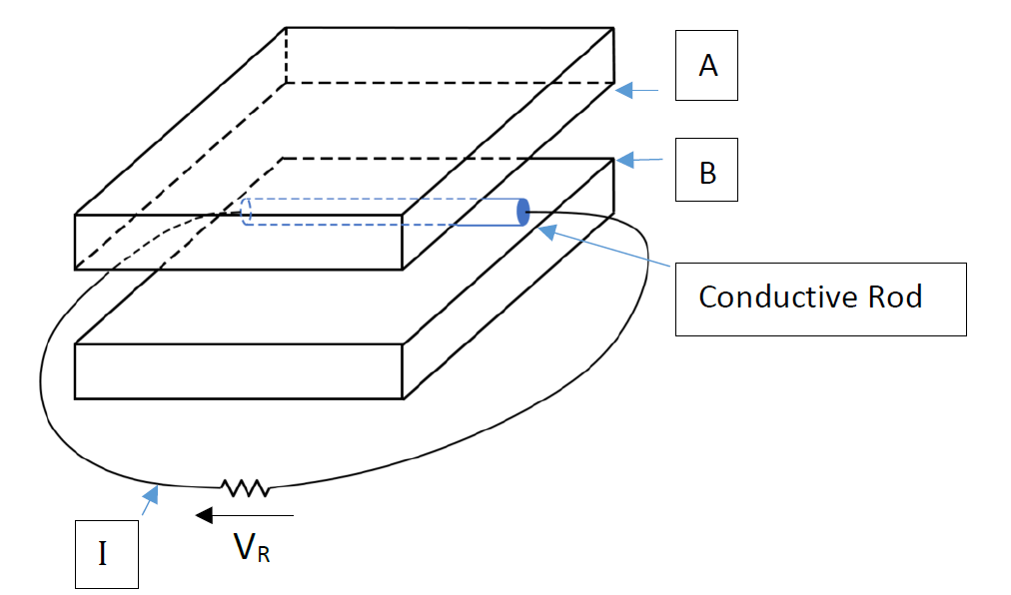

**The diagram is for answering Q6 to Q10**

1. Given that A is a North pole and B, a South pole, what is the direction of the current, if any, when the rod is moved at a velocity forward?

The current flows from left to right/ right to left / no current at the point marked by I.

1. Given that A is a North pole and B, a South pole, what is the polarity of VR when the rod is moved at a velocity forward?

VR is negative/positive.

1. Given that A is a South pole and B a North pole, what is the polarity of VR when the rod is moved at a velocity forward?

VR is is negative/positive.

1. Given that A is a North pole and B, a South pole, what is the direction of the Lorentz force generated that acts on the rod, if any, when the rod is moved at a velocity forward?

The rod experiences a force forward/backward/upward/downward/no force

1. A downward pointing uniform magnetic field of 0.2 Tesla is created by the magnetic poles A and B and the rod is 0.1 m long. Determine the direction and the magnitude of the force on the rod when the current is 10 A flowing from left to right at point marked by I.
2. A 200 V, 10 A, 1200 rpm separately-excited dc motor has an armature resistance of 0.8 Ω. It is driven by a chopper taking its supply from a 250 V dc source. Determine the duty cycle of the chopper when the motor is exerting the full-load torque at ½ the rated speed. The armature current is assumed to be continuous.  **Ans: 41.6 %**
3. A 200 V, 10 A, 1200 rpm separately-excited dc motor has an armature resistance of 0.8 Ω. It is driven by a chopper taking its supply from a 250 V dc source. Determine the duty cycle of the chopper when the motor is exerting 60 % of full-load torque at the rated speed. The armature current is assumed to be continuous. **Ans: 78.7 %**
4. A 200 V, 10 A, 1200 rpm separately-excited dc motor has an armature resistance of 0.8 Ω. It is driven by a chopper taking its supply from a 250 V dc source. Determine the duty cycle of the chopper when the motor is exerting 60 % of full-load torque at ½ the rated speed. The armature current is assumed to be continuous. **Ans: 40.3 %**